Intermediate Algebra Lecture 7.5: Solving Rational Equations (Equations with Rational Expressions)

Steps
- Find the LCD (lowest Common denominator) (factoring maybe required)
- Multiply every term by the LCD (DO NOT DO THIS lcd/lcd) * this will eliminate denominators

Example
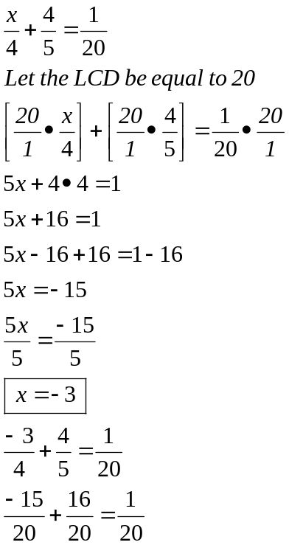

Example
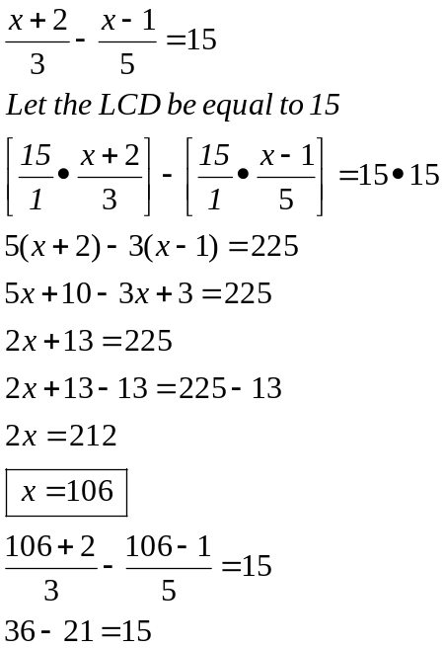

Example
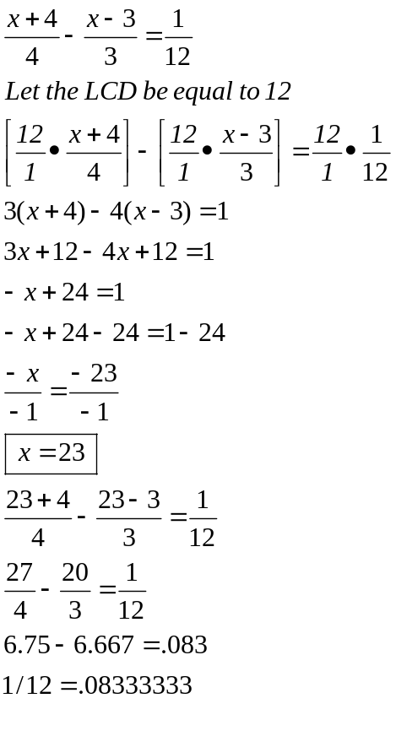

Example
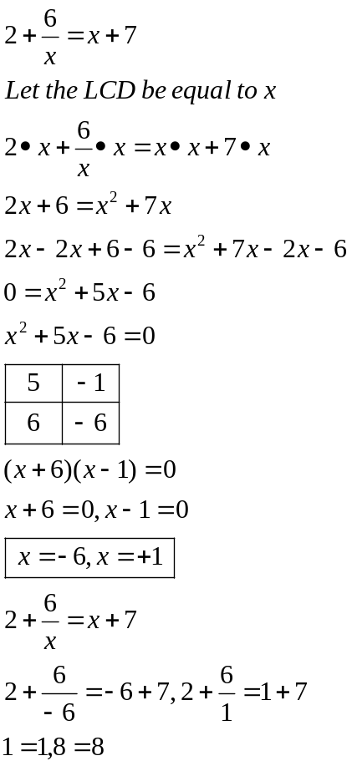

Example
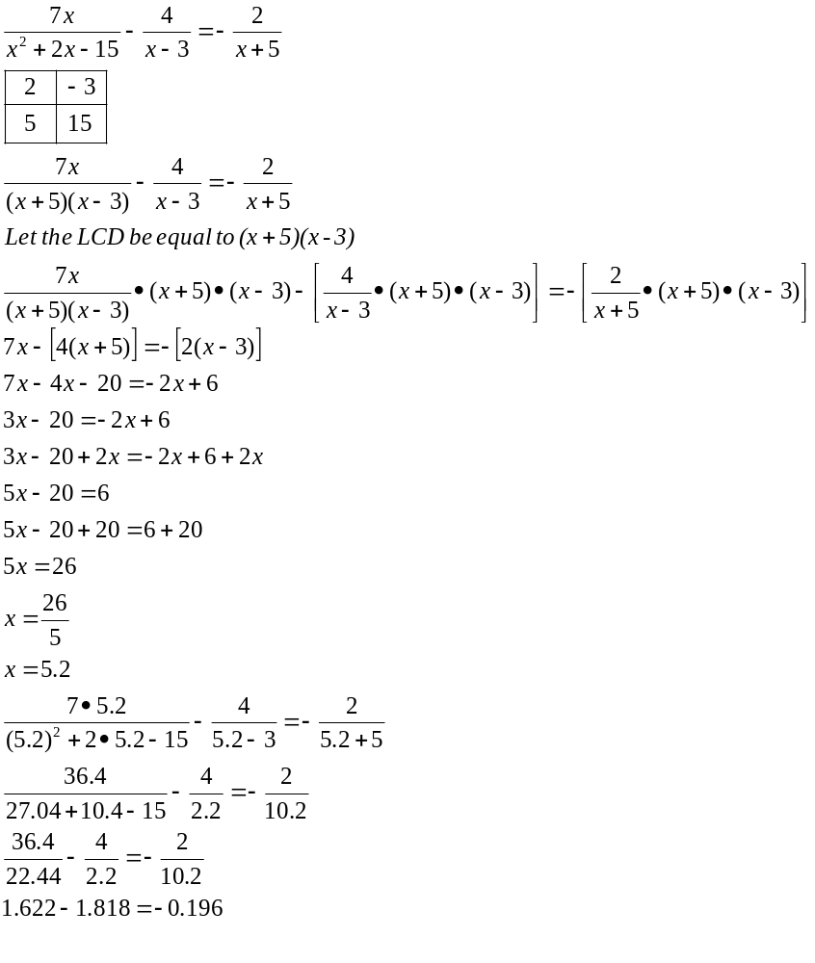

Example
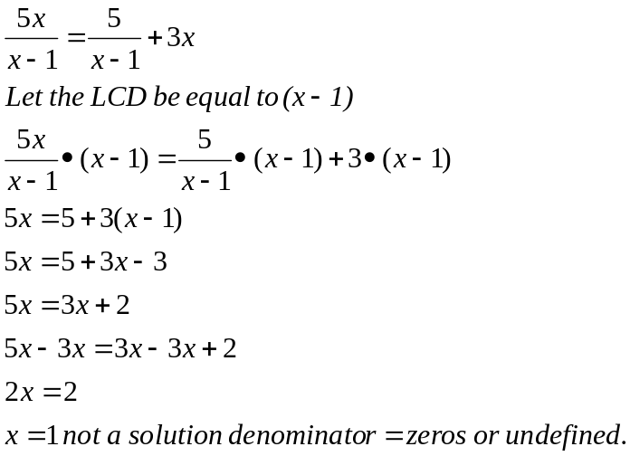

Example
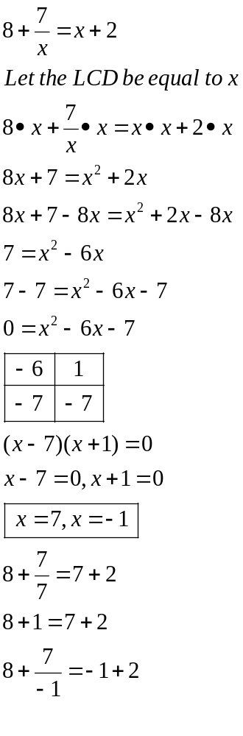
Example
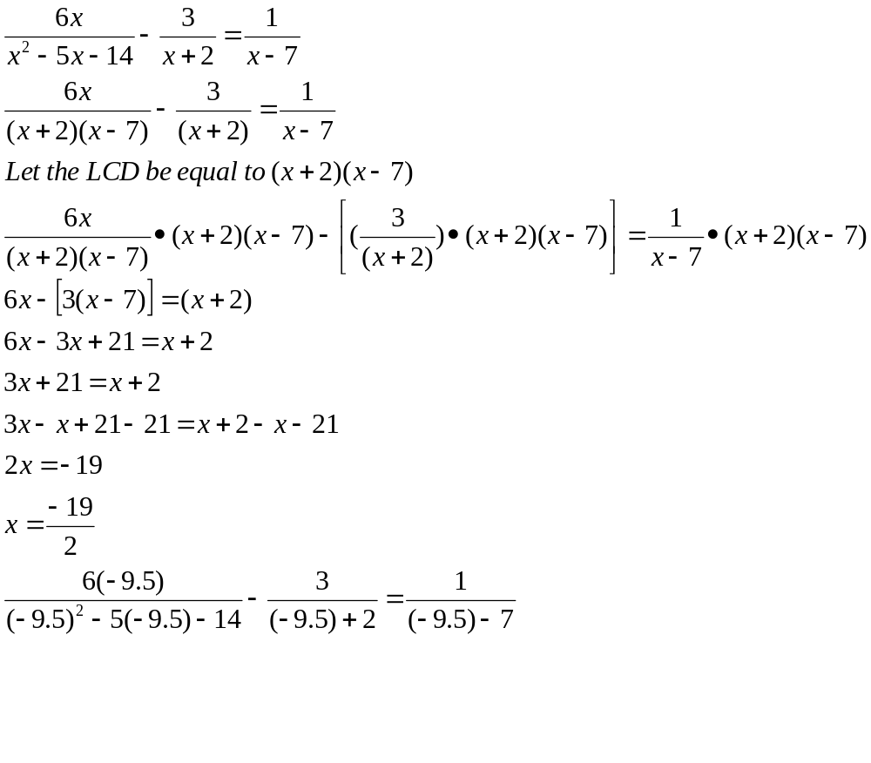

Example
